**Appendix 7**. A summary of the 1,581 cities included in the analysis.

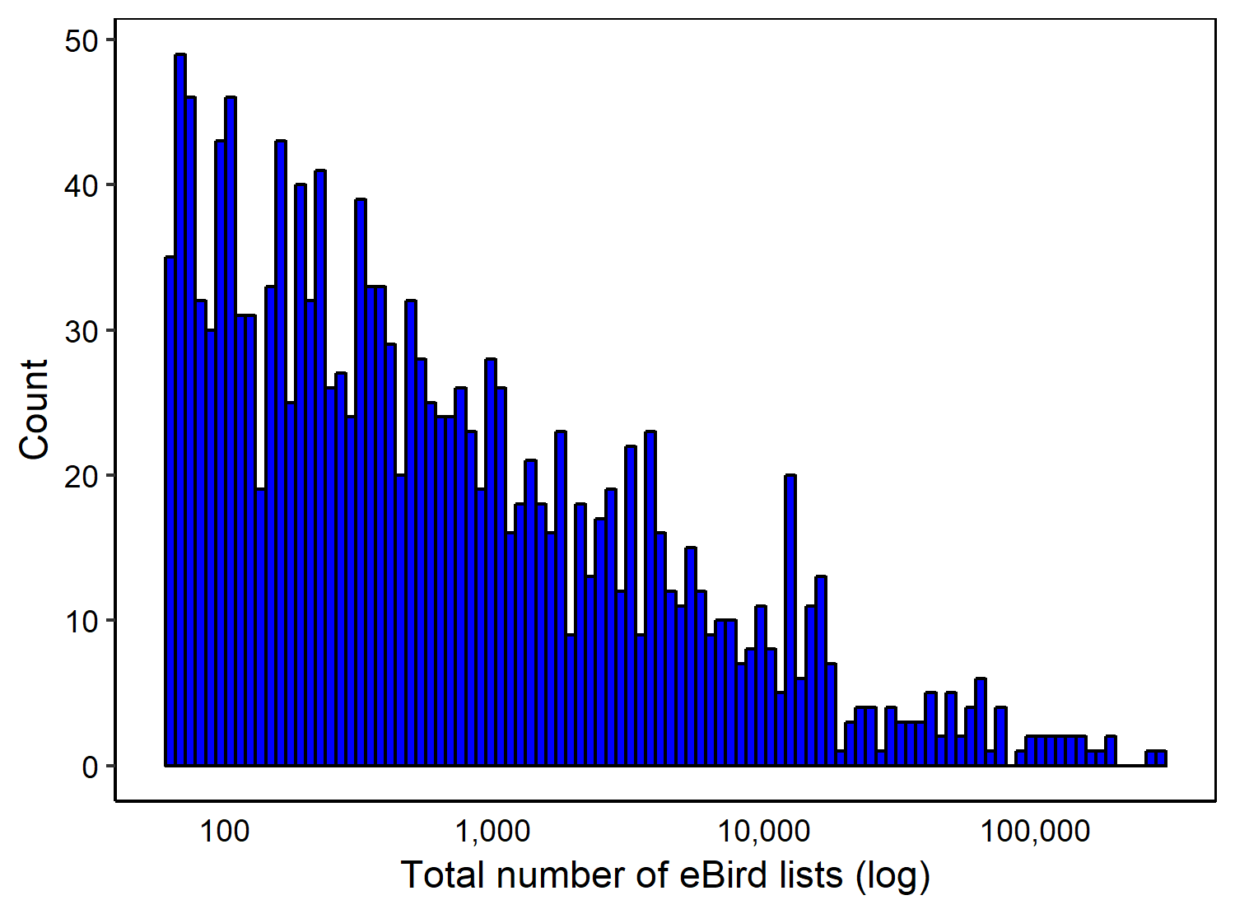

**Figure A1**. Histogram showing the number of eBird checklists (on a log-scale) included in the analysis, per city. The mean number of checklists included in the analysis, per city, was 3219.